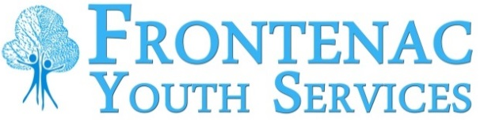

FRONTENAC YOUTH SERVICES
ACCESSIBLE CUSTOMER SERVICE FEEDBACK FORM

Frontenac Youth Services is committed to providing high quality customer service. We value all of our customers and strive to meet everyone’s needs. We welcome your comments to help us monitor and improve our services and experiences. Please submit your completed form to any of the following:

Mail or deliver to: Fax to: Email to:
Attn: Human Resources 905-723-7059 reception@frontenacyouthservices.org
Frontenac Youth Services
1160 Simcoe St. S.
Oshawa, ON L1H 5L8

Please tell use the date, time and location of your contact with us:

DATE: (YYYY-MM-DD) TIME: LOCATION:

Did we respond to your customer service needs:
Yes ____ No ____ (please explain below)

Please provide details of your customer service experience. (Use extra sheet if necessary.)

… next page
If you wish to be contacted by a staff person, please provide your information:

Full Name | Telephone # (day)  (___) _________________ Telephone # (evening)  (___) _________________
Address | Email Address

Personal information completed on this form is collected pursuant to Ontario Regulation 429/07, the Accessibility Standards for Customer Service and will be used for the purpose of responding to your request. Questions should be directed to Human Resources – Frontenac Youth Services 1160 Simcoe St. S., Oshawa, ON L1H 5L8.

